**Manuals for ‘Manage Career Position’**

**Brief of the ‘Manage career position’ –** This is the page where we manage career position.

**1. How to manage career position-.**

Steps:

1. Login to the site and go to ‘Career’ tab and click on ‘Manage position ’.
2. On ‘Manage career position’ page the listing of position and ‘Add career position’ button will display.
3. On this page we can edit and delete the existing records.
4. Click on ‘Add career position’ button for add new position.
5. The added new career position will display with career page.

1.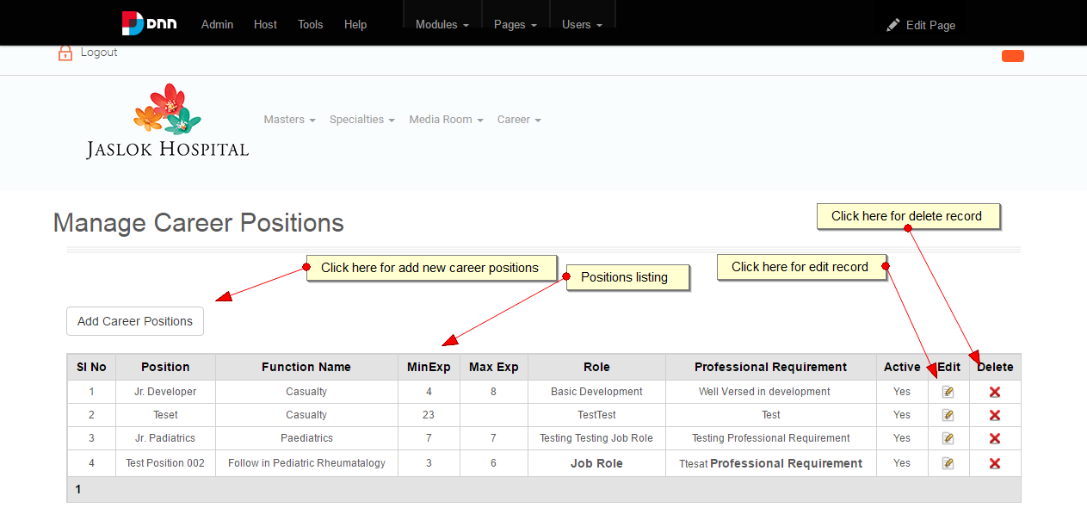

2.

